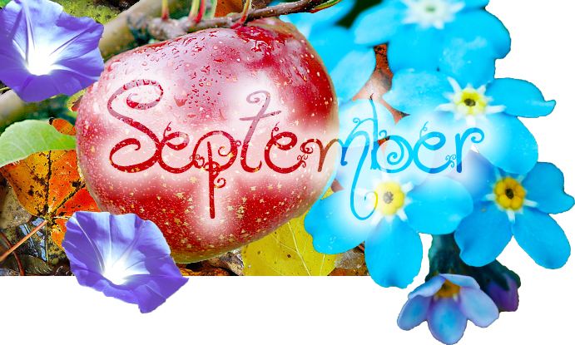
NATIVITY LUTHERAN CHURCH OF WEEKI WACHEE
6363 Commercial way, Weeki Wachee, FL 34613
Sunday Worship 8:30 & 11:00 am
Sunday School & Adult Studies 9:45-10:45 am
352-597-1456

“With the birth of Jesus in our hearts we carry light and love to the world”

In case of emergency, contact the office at 352-597-1456.

Website: nlcww.org

Please see Cindy in the nursery.

SPIRITUAL LIFE
NATIVITY LUTHERAN CHURCH COUNCIL
PROGRESS REPORT
JANUARY – JUNE 2017
At the inception of my term I stated that there were several things we must take into consideration and questions we must ask ourselves.
Questions such as, where did we come from? Where are we now? Where do we want to go? How do we get there? It’s not that the honeymoon is over with our new pastor, because we have seen him ‘dug in’ and faced the many challenges with charisma and most of all a great sense of faith and a confidence that God always work things out in His time.
Pastor and I have been meeting on a weekly basis, these meetings do bring a sense of cooperation and support as we put our heads together to bring issues to Council. We have also met with the ministries here at Nativity Lutheran to see their work in progress. Our Pastor has been networking with ministers from other denominations in the community to see how Nativity can cooperate in solving some of the issues facing us and the entire community.
Negotiations with Crown Castle for transfer of the Cell Tower were successfully completed, all funds were dispersed as recommended by the Finance and Tower Committees. Meetings with administration and maintenance personnel were held for performance updates, this resulted in the updating of job descriptions. This should improve and enhance their performances with services to Nativity.
The lack of communications has been addressed with the establishment of the Communications Committee. While still a work in progress, the outlook is great and with the Social media, Radio programming, and Website platforms, Nativity Lutheran will have an open door to the world. The Website will also have information readily valuable about Nativity Lutheran to the congregation and its many ministries, to prevent conflict when scheduling events.
The reorganization of the Mutual Ministries is gradually progressing as ministries and committees reformat, there is added interest as being in concert with the communications committee everyone will be informed in a timely manner.
We reached out to members who have not attended church for some time to check on their welfare and status to find out what can we do to have them return to Nativity. The reasons were varied and taken into consideration, but were also respected. We will keep them in our prayers.
The Property Committee has been hard at work upgrading the lighting on the campus to LED lighting. With this new energy efficient lighting the church should see a reduction in the energy bill over time. During the annual audit and a subsequent first quarter audit, concerns were expressed over the use of the Nativity Credit card. This concern was addressed with the Treasurer and office manager and procedures are in place for control.
The goal of Council to have a Youth Committee in place to oversee the needs of youth at Nativity Lutheran and the community has been reached. This was through the efforts of the Lay Leadership Committee chaired by Carlan Helgeson. Finding candidates to fill vacancies on Council has been a daunting and disappointing task, the reason brought my attention is the afternoon timing of the meetings. Members who are interested are still in the work force and declined because of the time constraint. The interest is there but a change in meeting times must be made and is currently being contemplated by Council.
Reports by the Treasurer and Financial secretary indicate that even with a decline in attendance, giving has been a little below budgeted however not to the point of placing us in great financial danger. Thanks to all members who have answered the call for increased giving, we will maintain composure moving ahead and staying in focus. While remaining on course and embracing the future, we should observe trends and make the necessary adjustments to bridge the gap between current members, and those we are trying to reach out to because we want them to be a part of our church family. With God’s help and our Faith, we can hopefully achieve our goals. Al Wright
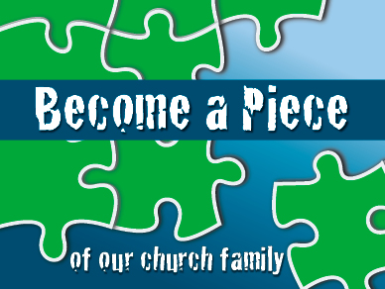
Inquirers Class and Orientation to Nativity:
Saturday, September 23, 2017, 10:00 am - 2:30 pm, lunch included
Whether you are new to Lutheran Theology or a lifelong Lutheran, you may enjoy a class that explores the basics of Lutheran doctrine such us Grace, Redemption, Sanctification, Mission, and more. We will also go over Spiritual Gifts, structure and ministries at Nativity. If you have a conflict with the date, please know that the class is offered in the Winter and in the Fall. The following themes will be explored.
- Why do we need a Lutheran Theology? What is Grace? How do Lutherans read and interpret the Word of God?
- Sacramental Life and The Holy Trinity.
- What do we mean by “vocation”? What is mission and why and how is the Church involved?
- Law & Gospel; Saints & Sinners; the Two Kingdoms.
- Spiritual Gifts Inventory.
- Structure and Ministries.
Register by contacting the church office at 352-597-1456, mark your interest to attend on the back of a pew card in church or send an e-mail to Pr. Giuseppe at pastormattei@nlcww.org.
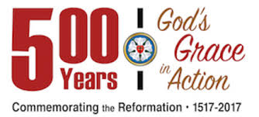

fbsynod.org

What happened in the Reformation?
Martin Luther posted his “Ninety-Five Theses” in Wittenberg on Oct. 31, 1517, and the resulting debate about Christian teaching and practice led to changes that have shaped the course of Western Christianity for almost 500 years. At the heart of these wide-reaching changes was a deep conviction that God’s mercy or grace in Jesus is given freely to all. When Luther and others learned to trust God’s mercy with “a living, daring confidence,” they discovered in that faith the freedom to give themselves generously, lovingly in all of life’s undertakings with everyone they met.
The changes began with a critical look at confession and forgiveness, preaching and the sacraments — what Luther called the “means of grace.” The sale of indulgences, the practice of penance, the content of preaching, the administration of Baptism and the Lord’s Supper — all the restrictions that impeded the message of God’s mercy from being heard and received fully by all came under scrutiny. Repeatedly, Luther made changes and took initiatives to give full and free expression to the gospel, the message of God’s liberating mercy in Jesus Christ. He translated the Scriptures into German so that ordinary believers could hear the Word of God in their everyday language. He composed many hymns including “A Mighty Fortress” (based on Psalm 46) that put the Word of God to music, the language of the heart. He preached for the people in Wittenberg in simple, everyday terms, and he used those sermons as the basis for teaching resources that parents and local pastors could use — his Small and Large Catechisms.

Why is the Reformation still relevant?
The Lutheran Reformation offers to Christian communities everywhere a liberating way of listening to and speaking the Scriptures. The Reformation teaching that Christ’s life flows through faith into a life of service to the neighbor is especially liberating in our culture today.
The evangelical Lutheran Reformation offers the promise of God’s love that makes possible a life of “living, daring confidence in God’s grace.”
The Reformation teaching that faith is the work of God’s Holy Spirit is especially liberating in a culture that assumes a faith relationship with God is an act of human “free will.”

Many, both within Christian communities and beyond, are held captive by ideologies that limit the full scope of God’s mercy in Christ to demographic groups defined sociologically by certain beliefs, behaviors or experiences. The Reformation teaching that Christ’s life flows through faith into a life of service to the neighbor is especially liberating in a culture that makes religious life into a demonstration of one’s own worthiness and privilege to the disadvantage of others.

How is the ELCA observing the 500th anniversary of the Reformation?
The ELCA is one church body organized in three expressions — congregations, synods and the churchwide organization. Each expression has its functions, but all three share a common mission of doing God’s work in the world and proclaiming the good news of Jesus Christ. Congregations, members, synods and other institutions of the ELCA will be observing the 500th anniversary of the Reformation by a variety of events and activities in the coming years. Many of the local activities will reflect the magnitude of work being done on a national and international scale.
Some areas of engagement will surround acknowledging what Martin Luther did to spark the Reformation, revisiting the roots of our Lutheran beliefs and what those roots mean today for us and our engagement with others.
In these activities, the ELCA seeks to find in this historic milestone an occasion to give a confident and joyful witness of the life and freedom in Jesus Christ that is for all.
YOUTH VS. ADULT GAME NIGHT

Nativity’s Youth will take on any of our Adult challengers at: Youth vs. Adults Game Night on
Friday, October 6th, 5:30 pm at Nativity. We will play Pictionary, Charades and other games.
Youth will supply the pizza and drinks. Signup sheet is on the kiosk in the narthex.

THE ELCA YOUTH GATHERING
Houston, Texas. June 27-July 4.
304 Days (as of August 26, 2017)
The USF College of Arts and Sciences and the Department of Religious Studies presents:
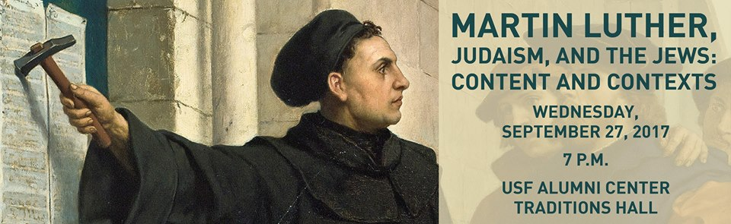

Presented by Dean Bell, Ph.D., Provost and Vice President,

Spertus Institute for Jewish Learning and Leadership.
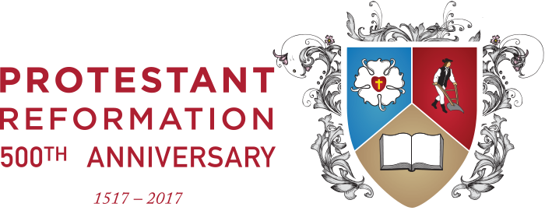
Martin Luther and the Protestant Reformation after 500 Years
Presented by Dr. Michael DeJonge. Chair
USF Department of Religious Studies
Monday, October 30, 2017 7:00 PM
USF C.W. Young Hall Room 206

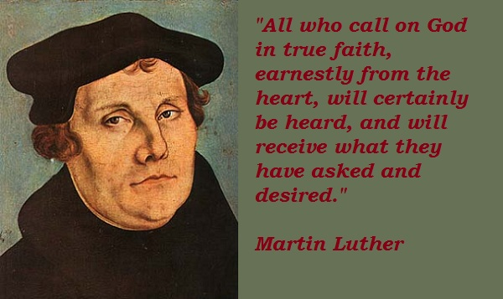

Luther’s Legacy in Germany’s Culture
Dr. Stephen K. Schindler, Chair
USF Department of World Languages
Thursday, February 8, 2018
USF C.W. Young Hall Room 206

USF is located at: 4202 East Fowler Ave. Tampa 33620

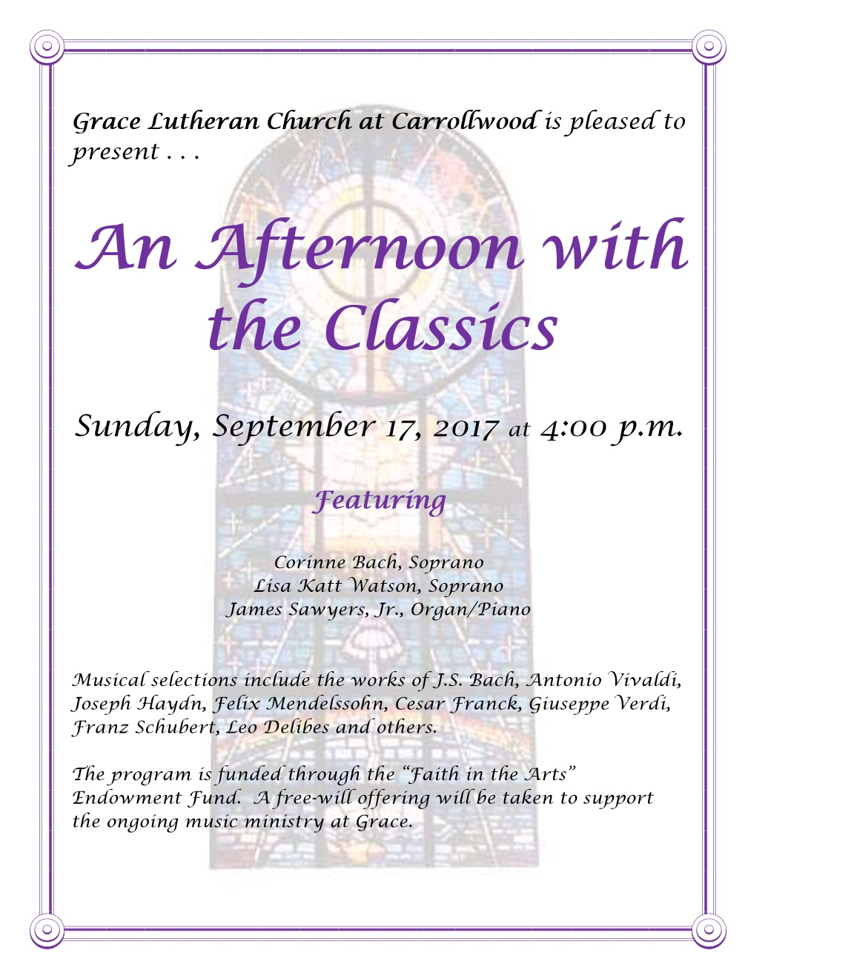
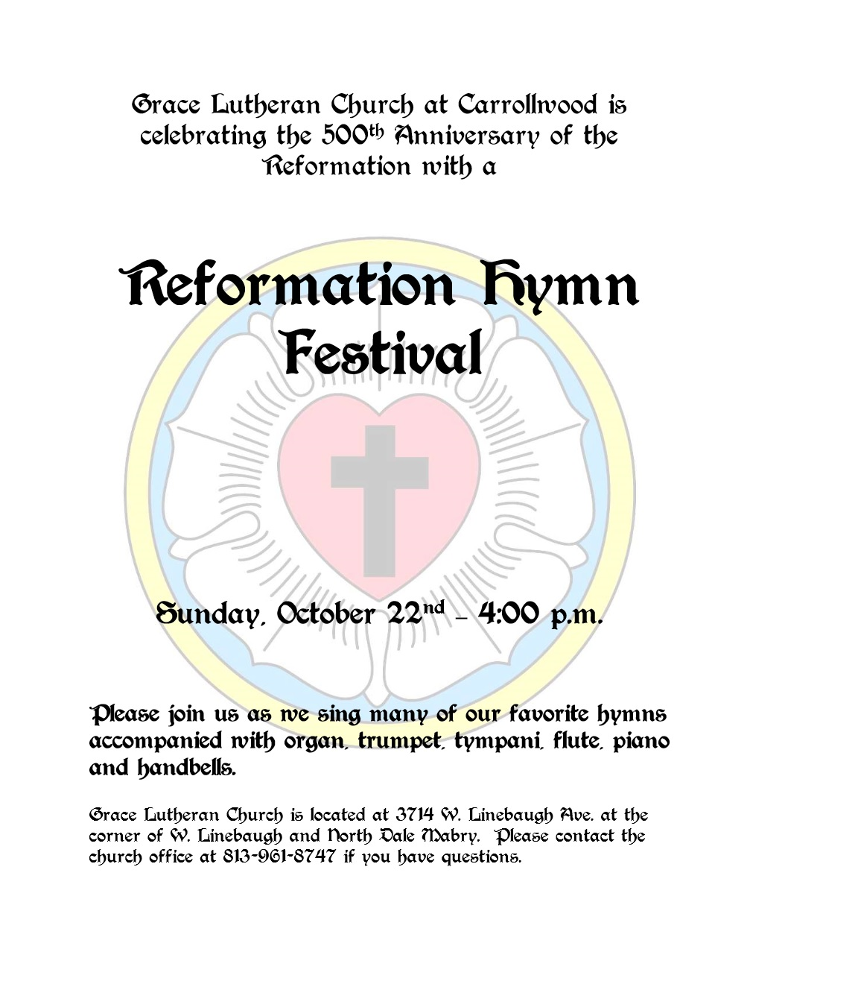

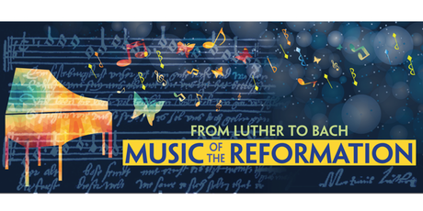

Concert Celebrating the 50tth Anniversary of the Protestant Reformation
Sunday, November 12, 2017, 4:00pm
First Presbyterian Church
St. Petersburg, FL 33701

Cantata No. 80, “Ein feste Burg,” BWV 80, Johann Sebastian Bach
Symphony No. 5 in D minor, “Reformation,” Felix Mendelssohn
Concordia Vocal Ensemble
Members of The Florida Orchestra
Dr. Matt Caine, conductor

Concert is free; tickets or advanced reservations are not needed.
A freewill offering will be received to help offset expenses.
Complimentary valet parking will be provided
Historical background

By the time composer Johann Sebastian Bach was born (1685), those who agreed with
Martin Luther (either for theological or for political reasons) had long since separated from the Roman Catholic Church, forming the Lutheran Church and other Protestant churches, and October 31 had acquired the status of being a feast day or holy day in these churches.
Bach composed at least one cantata to be used on every Sunday of the church year and on all holy days. His Cantata No. 80, “Ein feste Burg,” was written specially for use on Reformation Day, using as its primary musical material, the chorale text and tune written by Martin Luther, known in English as “A Mighty Fortress Is Our God.” This chorale is often colloquially known as the fight song of the Protestant Reformation.

In 1830, throughout modern-day Germany, municipalities were preparing to celebrate the 300th Anniversary of the Augsburg Confession, the primary confession of faith of the Lutheran Church. To celebrate this event, composer Felix Mendelssohn (who was singlehandedly responsible for the revival of performance of the works of Bach beginning with a performance of Bach’s St. Matthew Passion in 1829) began composing a church symphony for this celebration. He did not finish his symphony in time for the celebrations in 1830.
When he did complete his Symphony in D minor, he gave it the subtitle, Reformation. It only received a couple of performances in Mendelssohn’s lifetime and was not published until after his death.
Unlike most symphonies, Mendelssohn’s Reformation Symphony (Symphony No. 5 in D minor) tells a musical story, in this case, evoking images of the Protestant Reformation, symbolized most overtly with a solo flute (the instrument Martin Luther played) beginning the fourth (and final) movement intoning the beginning of Luther’s “A Mighty Fortress Is Our God.” This chorale becomes the musical basis for the final movement.
There is no pairing of music more perfect than pairing Bach’s Cantata No. 80, “Ein feste Burg,” with Mendelssohn’s Symphony No. 5 in D minor, “Reformation,” for a concert honoring the 500th Anniversary of the Protestant Reformation given that both works were written with the Reformation clearly in mind, both works share some similar musical material (the chorale tune, “Ein feste Burg,” or “A Mighty Fortress Is Our God”) though treat the musical material in very different ways, and that Mendelssohn is the person responsible to restoring the music of Bach to its rightful place in the European musical canon after it had been largely forgotten.

CHRISTIAN EDUCATION
CONFIRMATION-Classes begin on September 2nd, 10:00am-12:30pm

RALLY DAY IS SEPTEMBER 10TH, 2017

Join us as our many activities and ministries resume.

ADULT FORUM 9:45-10:45 am
Adult Forum fall schedule for September-October-November
Sunday, September 10: Rick Steve’s DVD Luther: The Reformer.
Sunday, September 17: Introduction of New Website
Sunday, September 24: Germany’s Luther Towns
Wednesday, September 27, 7:00 pm - USF Lecture series: Dr. Dean Bell, Martin Luther, Judaism and the Jews. USF Alumni Center, Traditions Hall, 4202 E Fowler Ave, Tampa

Sundays in October: Reformation 1000
Monday, October 30, 7:00 pm - USF Lecture series: Dr. Michael DeJonge, Martin Luther and the Protestant Reformation after 500 Years, USF C. W. Young Hall, 12303 USF Maple Drive, Tampa

Sunday, November 12: Rick Steve’s' European Christmas
Sunday, November 19: A New Generation

SUNDAY SCHOOL meets in Al Lien Hall, 9:45-10:45 am

COMMUNITY NEWS
PATTER FROM PATTI
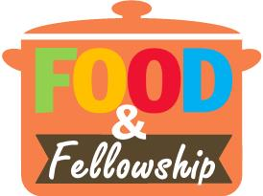
Well the calendar summer is almost over, of course for us Floridians we have a long way to go. Hope you all had a wonderful summer and are ready to dive into activities with your Nativity family. Here is what we have coming up:

Monday, September 25th MYSTERY DINNER Meet at church at 4:00
If you have never joined us for a Mystery Dinner, why don’t you try this? We will meet at church for some beverage and goodies and then proceed to the restaurant where we will have our own room and order off the menu with separate checks. I will only tell you this is a restaurant we visited awhile back. If you wish to attend we are accepting deposits of $10 per person starting Sunday September 3rd. Upon arriving at church on the day you will receive your deposit back. The best way is to just give us a check made out to Nativity Fellowship. We will not cash it, but will return it to you. If you tell us you cannot attend before the 23rd of August, you will also receive your deposit back. We can seat 60, so don’t wait.

Saturday, October 28th 5:00 REFORMATION FALL FESTIVAL
We are excited to offer our 3rd Fall Festival, this year tying it in with our observation of the 500th anniversary of the Reformation. What a weekend this will be. The doors will open at 4:30. Please bring lawn chairs if you are able and Luther League will take them from you as you arrive. You might want to bring a flashlight too. Here is how the evening will play out: At 5:05 we will start dinner consisting of: salad, potato salad, chips, baked beans, choice of brats or hot dogs, apple pie alamode. Then we will head out to the fire pit for a good old fashion sing a long led by Carlen and June. While there of course we need to roast marshmallows and have s’mores. Not my problem if the kids are on a sugar high and can’t sleep. They usually run around so much they wear themselves out. It should be a great family evening. We will start selling tickets on Sunday September 24th. They are $5.00 for adults, $1.00 for kids and Luther League is our treat. At the time of purchase, we will ask you for your selection of brats or hot dogs. We hear that the communication committee will be offering tee shirts for the event. We can seat 160, but we usually sell out, so if you plan to join us, buy early.
Word is out that we might have a visit from Martin Luther and his wife.... who would think???

Saturday, December 9th, SHOW PALACE CHRISTMAS SPECTACULAR. Doors open at 11:30
We will start selling tickets for the Show Palace on Sunday, October 1st. The Tickets are $45.00 per person and will include their buffet lunch. If you are new to the area the Show Palace is just down the road in Hudson. We have reserved 48 good seats, so it is first come. All tickets must be sold by November 9th. The shows are always excellent and filled with the Holiday music you love.
We still must figure out our November event, if you would like to help us our committee meets the second Tuesday of the month at 10:30. We always welcome new members and you will feel like part of our family in no time. I would like to take this opportunity to thank you for your messages of condolence on my Mother’s death. She lived for 96 years and now is with the Lord and those who have passed before her. If you have any questions about any of our activities don’t hesitate to give me a call at 352-797-9682 or pattiwithani@tampabay.rr.com . See you soon I hope. Patti Cotter
We are calling you to remember us on the 3rd Tuesday of each month @ 8:30 AM @ Perkins Restaurant, 4685 Commercial Way, Spring Hill.
Our next meeting will be held on Tuesday, September 19th, @ 8:30 AM @ Perkins. Please plan on being there.
Call Jim Christensen if you have any questions at 352-683-9141.

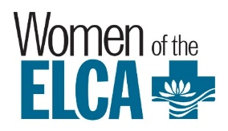
WOMEN’S CIRCLES
WOMEN OF NATIVITY

MARYJOY CIRCLE will meet Thursday, September 14th, 12:30 pm at Nativity for Bible Study and refreshments. Start the new season off with us. Our Bible study is from Gather magazine and the topic will be The Apostle’s Creed: We Believe in God.
Facilitator is Mary McDowall. Study Leader is Cam Martin. Hostesses are Cam Martin and Louise Weyen.
FRIENDSHIP CIRCLE will enjoy a potluck, devotions, a short meeting, and the sunset (7:26pm) at Pine Island on Saturday, September 23. Meet at Nativity at 5:15pm to carpool out to the beach. All are welcome. Contact Susan Nordstrom at 352-428-1918 for further information.
SARAH CIRCLE
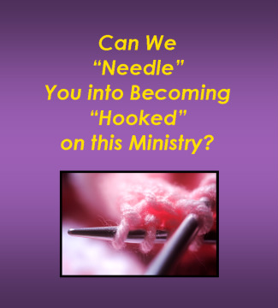
Calling all knitters, crocheters, or anyone interested in learning! Sarah Circle will meet Monday, September 18. We provide the yarn. Knit or crochet prayer shawls in all shapes and sizes to give to those hospitalized, grieving, or otherwise in need of prayer. Questions? Call Kim Mehan at 727-207-0071
Health. Education. Dignity. Ensure she has what she needs to succeed. These are the words found on the home page of the website for Days for Girls, a non-profit organization formed to help girls in developing countries stay in school. How can an organization help girls stay in school you may ask?
Consider this: When a girl has her monthly period, she stays in her room and sits on a piece of cardboard! She cannot go to school and falls behind in her studies, eventually dropping out altogether.
Days for Girls has come up with a solution: washable, reusable menstrual pads which are kept in a drawstring bag. Along with receiving these kits the girls are taught about health and personal hygiene. They are taught how to care for their pads so that they will last up to 3 years.
Through the Trompeter Fund and Thrivent Financial, Women of Nativity have been able to participate in this mission.
WON continues to have workshops to make the kits. The next one will be on Thursday, September 21st, from 9:00 am to 11:00 am at Nativity. Please consider joining us on this valuable mission project.
Contact Jill Helgeson at 352-686-3367 for more information or if you have any questions.
WOMENS CRAFT GROUPS
CRAFTY LADIES meet every Friday, 9:00-11:00 a.m. at the church in Al Lien Hall. We welcome anyone who would like to come and see what we are all about. Our group works on quilts and many steps are required to complete one. There are sewing machines at the church, if you are interested in sewing. The Ladies take time out for refreshments and fellowship about 10:30 am. We can always use old sheets and pillow cases; mark them Crafty Ladies before dropping them off at the church. All are welcome. Call Lilo Horeis 352-666-7584 with questions.

CARDS R US-Would you like to get creative and help finance Pastor's Discretionary Fund at the same time? If so, you will enjoy getting together with the Cards R Us group to make cards out of used greeting cards. We will be making cards on September 6 and September 13, 12:30-3:00pm, in Winemiller Hall. We furnish all supplies and tools. What we are missing is more willing hands. No experience necessary. Call Susan Nordstrom at 352-428-1918 for further information.
You are cordially invited to join the Altar Guild. We invite anyone (male or female) to attend one of our meetings on the 3rd Wednesday of each month at 10:00 am, (to find out what we do and how we do it), or if you have any questions you would like answered before that call Janet DeVico at 352- 597-0150.

OUTREACH
SEPTEMBER MISSION OF THE MONTH
HAITI GLOBAL MISSION
God's Work Our Hands Sunday, September 10

The ELCA has set aside Sunday, September 10 as this year's "God's Work Our Hands" Sunday, an opportunity for people of faith to serve their communities in intentional ways. Whether your congregation chooses September 10 or a different date to do a day of service, consider joining in this church-wide initiative to serve your community. If your congregation IS doing a day of service, feel free to share your stories and pictures with the synod office so we can celebrate and give thanks with you! You can email pictures and stories to Sr. Michelle Collins (michellec@fbsynod.org).

This October, as we observe the 500th anniversary of the Reformation, join us for Global Church Sunday by celebrating and supporting our church’s missionaries! No matter who they are or where they serve, every missionary needs your prayers, support and gifts to live out their ministry.
Each year, more than 225 ELCA missionaries, including Young Adults in Global Mission, serve in more than 40 countries around the world. They are sent by the ELCA in response to invitations from our companion churches and serve in a variety of roles, working alongside our companions to proclaim the gospel, raise up leaders, care for those in need and develop new ways of being church together.
If each of the ELCA’s 9,300 congregations made a gift of $500 or more to Missionaries and Young Adults in Global Mission in commemoration of the 500th anniversary, we could raise nearly $5 million for these life-changing ministries. This is a historic milestone for the Lutheran church and an exciting opportunity to participate in the ongoing Reformation. Will you join us?
Have questions or looking for other ways to get involved? Contact the Global Church Sponsorship team at 800-638-3522 or globalchurch@elca.org.

Alfred and Gertrude Korndoerfer 9/2
Tom and Galina Maras-Kestleloot 9/3
Charles and Nettie Wingrove 9/5
Edward and Carol Fournier 9/9
Clyde and Rosie Rosten 9/9
Jim and Judy Ward 9/9
Bill and Charlotte Hamm 9/12
Merritt and Pat Wilkins 9/12
Dennis and Pam Rogers 9/17
Patrick and Darlene Gould 9/18
Giuseppe and Stephanie Mattei 9/19
James and Joanne Stuck 9/21
Dieter and Margret Steffens 9/26
Bob and Jan Brown 9/28
Leonard and Dottie Outhouse 9/30
Krystal McCausland 9/1
John Cain, Dennis Rogers 9/4
Kayla Patterson, Nettie Wingrove 9/5
Helen Bies 9/7
Lorrie Defrancesco, Cheryl Zybell 9/8
Ruth Ann Hoy, Judy Ward 9/9
Marlene Chinnici 9/11
Guy Peeters, Wayne Rasper, Gaylon Swenson 9/12
Madison Gould 9/13
Laverne Wilson 9/14
Dolores mrozowski 9/15
Rich mraz 9/16
Glenna Snyder 9/17
Larry Anderson, joanne manos 9/18
Phyllis simpson, alice wells 9/20
Mary mcdowall 9/21
Heidi maclean 9/22
Kathy Olsen 9/24
Gert korndoerfer 9/25
Margret raeder, bob strohl 9/26
Charles Brown, beryl clements, kendall white 9/27
Philip bruden 9/28
Jayson martin, raina mcdannold 9/30

