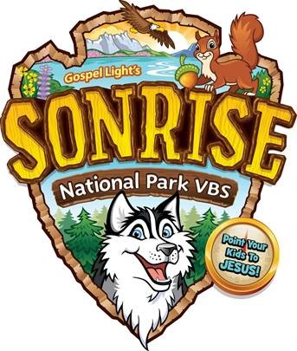
Join Us As We Explore SonRise National Park
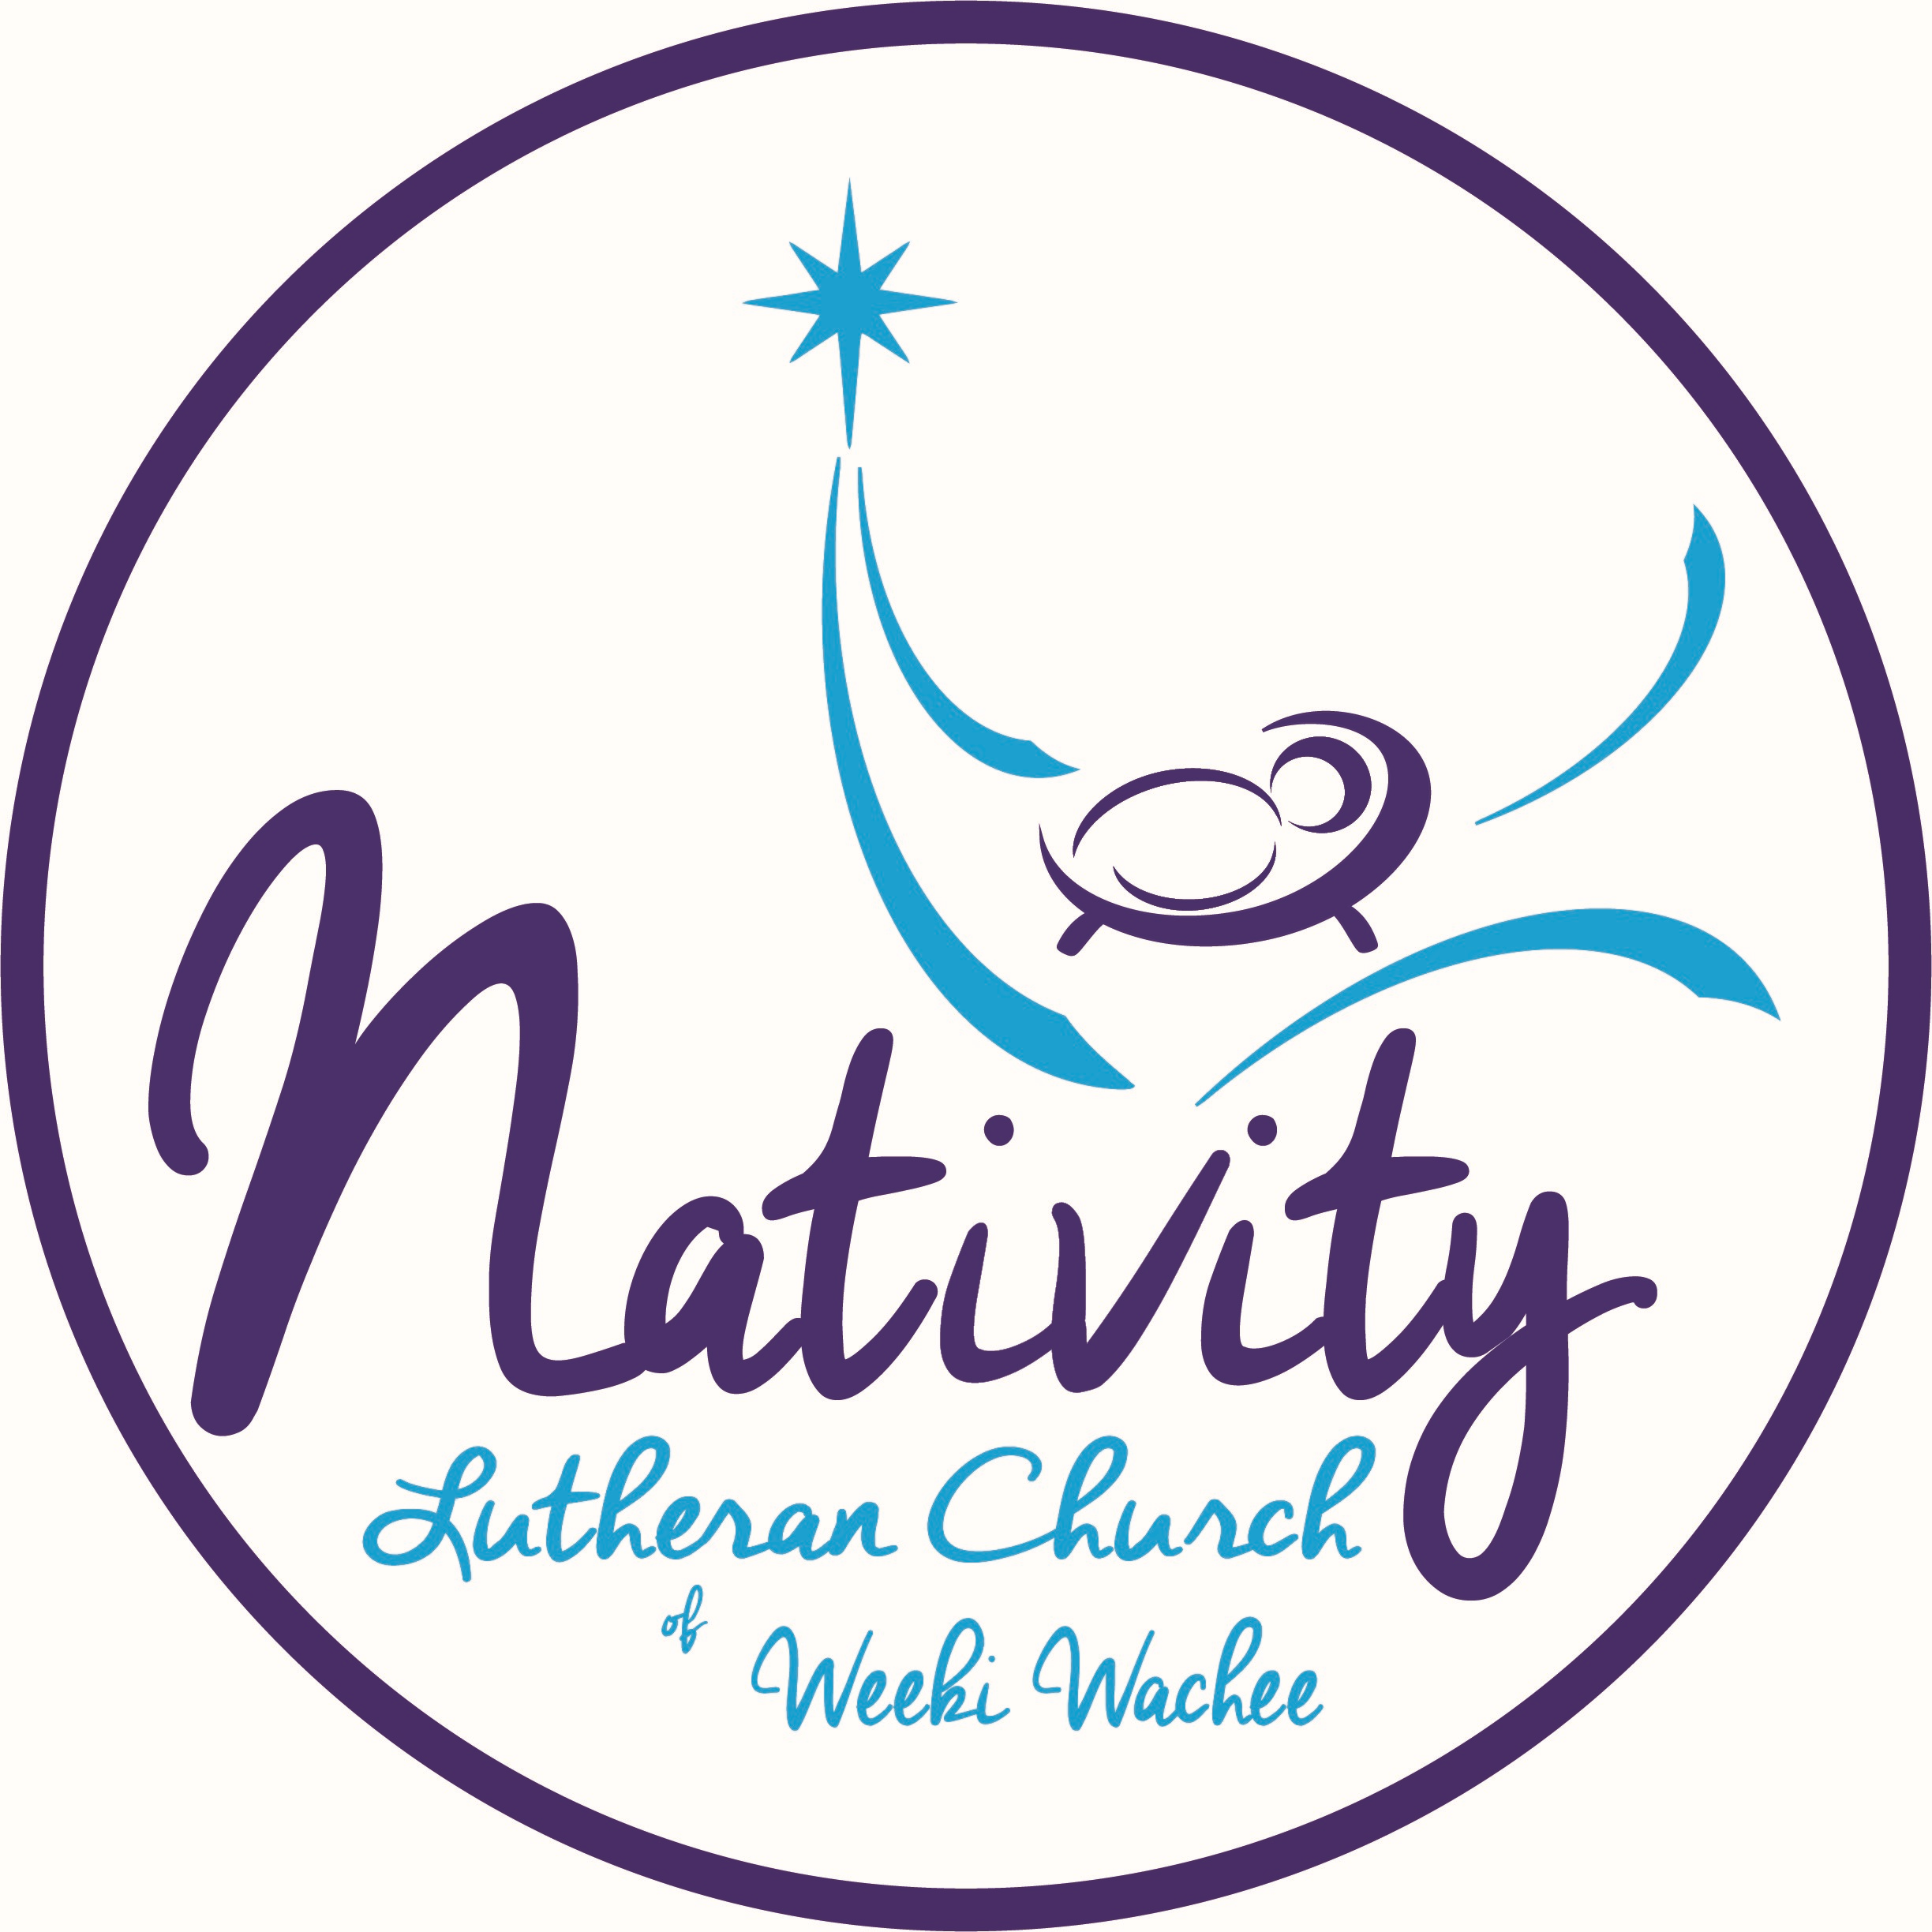
To Learn About God’s Love
June 18-22, 2018 9:00 am – 12:15 pm
Nativity Lutheran Church
6363 Commercial Way, Weeki Wachee, FL 34613
(352) 597-1456
Email: Nativitylutheran63@gmail.com
Website: nlcww.org • Like Us On Facebook!

Children age 3 (potty trained) through 12 are welcome. Teens age 12+ are welcome to be Junior Guides (helpers). Bible Stories, Crafts, Skits, Games, Songs, Water Slide, Snacks, and a free lunch for all.

PRE-REGISTRATION
Completed
Child’s Name ______________________________ Age ____ Grade _______
Completed
Child’s Name ______________________________ Age ____ Grade _______
Completed
Child’s Name ______________________________ Age ____ Grade _______
Completed
Child’s Name ______________________________ Age ____ Grade _______
ALLERGIES ______________________________________________________

Parent/Guardian Name ____________________________________________
Address _________________________________ Email __________________
City/State/Zip _______________________ Cell Phone ___________________
Your Home Church _____________________________
Would you like to help at VBS? ____________________
How did you hear about us? ______________________

